**User Personas**

**Persona 1**

|  |  |
| --- | --- |
| Name | Olivia |
| Age | 23 |
| Bio | Olivia is just getting into gardening and doesn’t know a lot about the natural life cycles of her plants. |
| Problems | Olivia wants to buy seeds for plants she can grow today but is unsure what is best for this time of year, or her area. |

**Persona 2**

|  |  |
| --- | --- |
| Name | Linda |
| Age | 66 |
| Bio | Linda has been gardening for a while, and likes to plant a wide variety of plants. She knows specifically what she is trying to plant, and knows the general times of year when is best for planting |
| Problems | With such a wide variety of plants, Linda can sometimes forget to plant one or two. Linda needs a way to see all the plants she plans on having this year, and know when to plant each one. |

**Storyboard 1**

Problem: Olivia wants to see what plants she could plant in her area today.

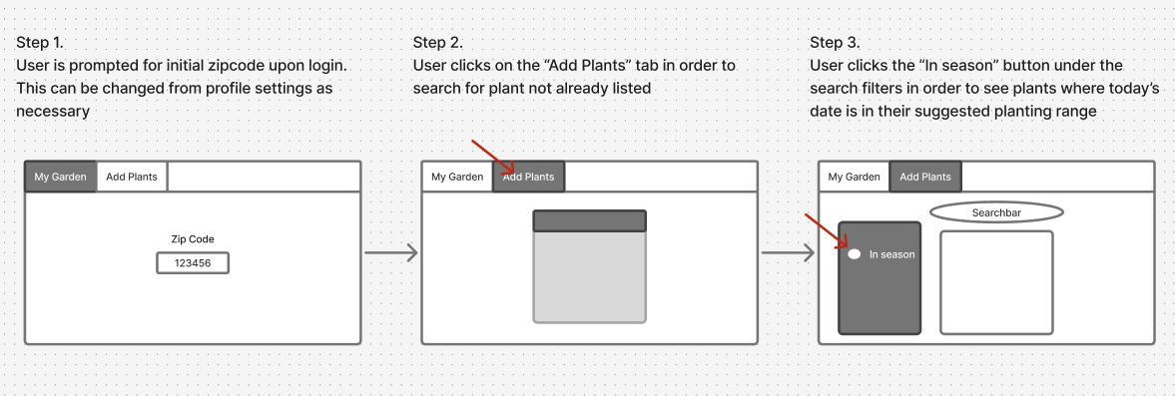

**Storyboard 2**

Problem: Linda wants a way to see which of the plants the is planning on planting are ready to plant right now.

**StoryBoard 3: Stretch**

Linda likes having all the information she needs about what to do in her garden before she goes outside. Knowing what kind of weather is approaching in the next few days would help inform her watering and care habits today.

